|  |  |  |
| --- | --- | --- |
| ASE Group Project - Documentation | December 12  2012 | |
|  | |  |

Group 4:

Sean Chapman: Candidate Number: 102223

Jolanta Rusecka: Candidate Number: 102150

Chris Walker: Candidate Number: 102227

[Andria Orphanidou](https://plus.google.com/u/0/101226752234022848438?prsrc=4): Candidate Number: 102148

Ewen Cluley: Candidate Number: 102230

Contents

1. Introduction 1

2. Planning products 1

3. Requirements documentation 2

4. Use case model 3

Use case diagram 4

4.1 List of actors and descriptions 5

5. Class diagram 5

# Introduction

This document consists of the following:

* Planning products
* List of requirements
* Use case model
* Class diagram

# Planning products

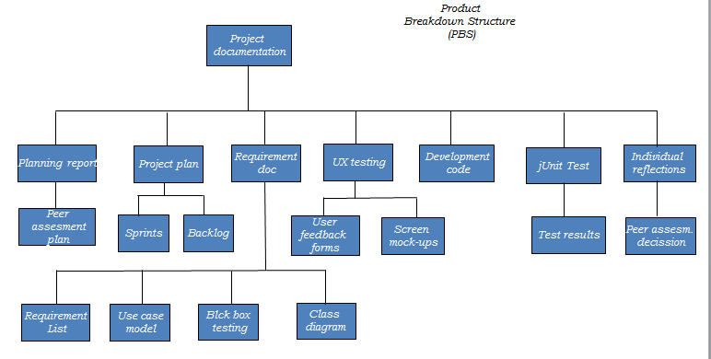

# Requirements documentation

Android App – Clock and GPS location display

Extension 1

Extend the App you have already produced so that periodically it signs in to an internet service with its location

Extension 2

Extend your application so that the user of the App can "check in" to particular locations. They should then be able to see when other users of the app have visited the same location.

Extension 3

Final extension: App users can view other app user's location. App users can see other users' ratings and/or reviews, as well as enter their own reviews.

The requirements are grouped into following categories:

* Functional
* Non-functional requirements
* User requirements
  1. **Functional requirements**

The new system must be able to allow to:

1. The system should allow user registration and verification.
2. The system should grant [access](http://www.modernanalyst.com/Community/Forums/tabid/76/forumid/17/postid/4092/scope/posts/Default.aspx) to the user after he provides username and password.
3. The system should remember the user credentials, if user specifies wishes to do so.
4. The system should display periodically updates gps location, and current time.
5. The system should provide read access of the following: other user comments, places description.
6. The system should allow the user to create comments and add new places to the system.
7. The system should allow the user to check into places.
   1. **Non-functional requirements**

The system must be able to implement functional requirements in a following way:

1. Interoperability. Aapplication allowing concurrent users login. Application works the same on different versions of Android operating systems and various Android devices (tablets, phones).
2. Usability. Ease of use and user friendly design.
3. Reliability. The consistent performance of the system. For example: All buttons support their required performance.
4. Scalability. It is possible to development additional functionalities and system can cope with increased volume of user’s without its performance being affected.
5. Secure system. Access restrictions. Unique Login details required, user verification required.
6. No inconsistent or repeated data allowed.
7. No data loss allowed.
   1. **User requirements (Backlog)**

Additional user requirements have been collated in the Project Backlog, located in GitHub Repository under PM Documentation.

## 4. Use case model

1. Register new user
2. User log in
3. Display GPS location
4. Display Time
5. Periodically update user location
6. Check into places
7. Display places in X radius
8. Display other user location in X radius
9. Add a place description
10. Add a comment
11. Display comments

### Use case diagram



## 4.1 List of actors and descriptions

|  |  |
| --- | --- |
| **Actor** | Description |
| Unregistered user | * Register |
| Registered user | * Log in * Check into places * Add a place description * Add a comment |
| System | * Uploads data to server * Display places in X radius * Display other user location in X radius * Periodically update user location * Display GPS location * Display Time * Display comments * Display other user comments |

## 5. Class diagram